Step 1: Setup Your Bot and Establish Relationship
(without this step, the bot will never be able to message you)
Expected Time: 5-7 minutes

- Log into https://discord.com/developers/applications
- Select “New Application” (top right corner, blue box)
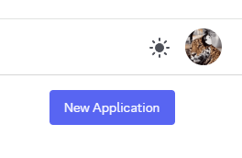
- Give it a name, e.g. “StashSageDemo”
- Go to “Bot” tab on the left menu, under Privileged Gateway Intents, enable the 3rd option: “Message Content Intent” and Save Changes.
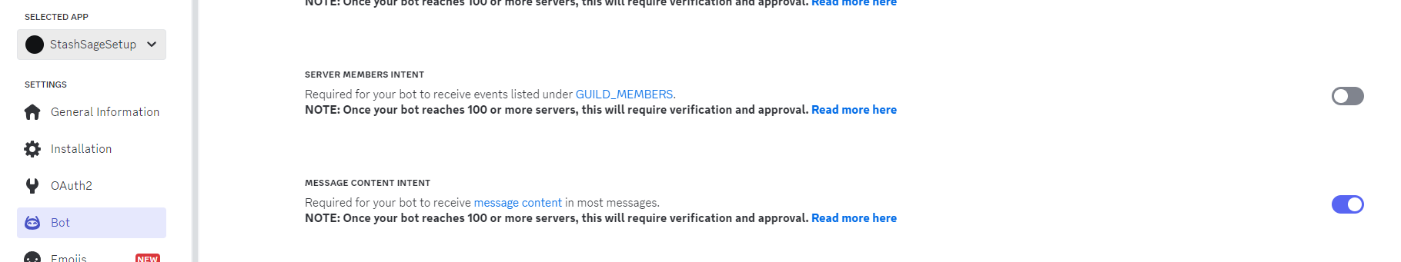
- Go to Discord, on the left bar with your list of servers, click the “+” button to create a new private server (Create My Own > For Me & Friends). Name it something like “iLoveStashSage”. Do not delete this server, as a bot must always be in a server with you to message you.
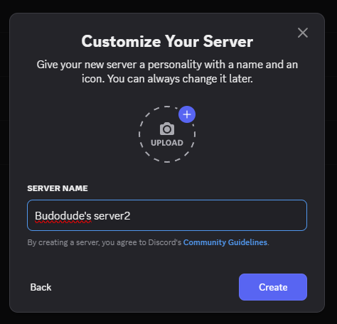
- Enter the following link into your browser, replacing the “YOUR_BOT_APPLICATION_ID” with your bot’s Application ID, which can be copied from the “General Information” tab in the Discord Developer menu.
https://discord.com/oauth2/authorize?client_id=YOUR_BOT_APPLICATION_ID&scope=bot&permissions=8
For example:
https://discord.com/oauth2/authorize?client_id=1353378058813132921&scope=bot&permissions=8
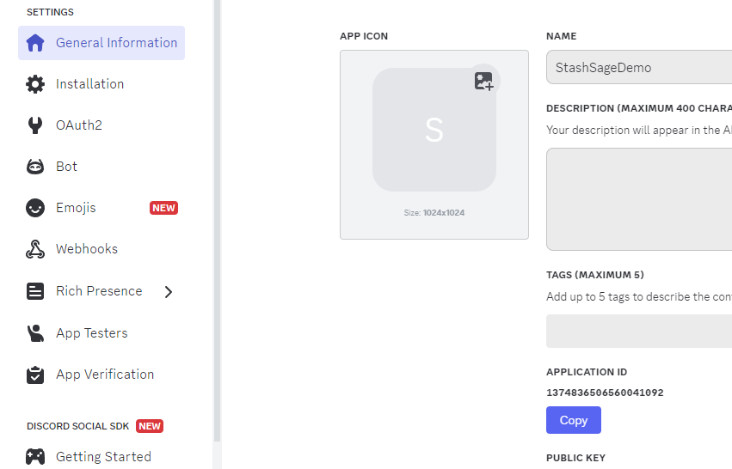

- You should be redirected back to your Discord app. Invite the Bot to your server. Right click or double click the bot, “Message” it something, and you’re done! You have established a relationship with your bot. It can now send you messages. Keep the server running and do not delete it!

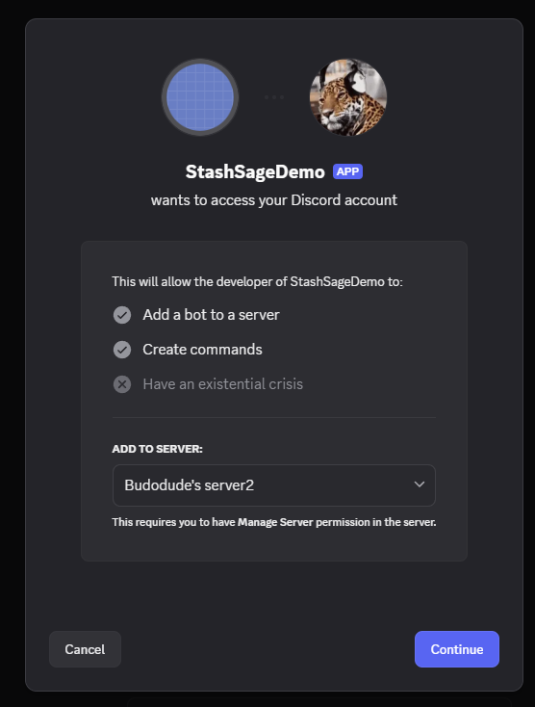

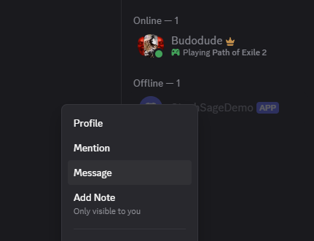

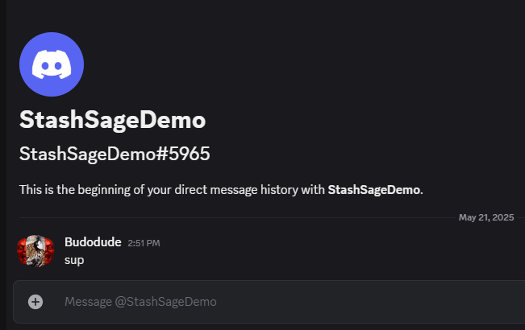
Enter your User ID and Bot’s Token into StashSage
Expected Time: 3-5 minutes
When you first install and load the StashSage application, you will need to enter your Discord User ID and your Discord Bot Token into the menu, and then select “Save Settings & Reload”. You only need to do this once, as the application will save your credentials for future logins in your local APPDATA.
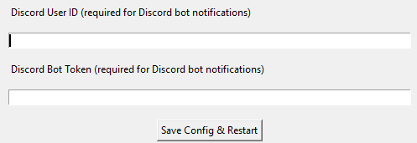
- Go back to https://discord.com/developers/applications
- Select your bot application (e.g. “StashSageDemo”) in the left tab dropdown.
- Go to “Bot” menu, and either Reset Token (if unable to Copy) and/or Copy Token.
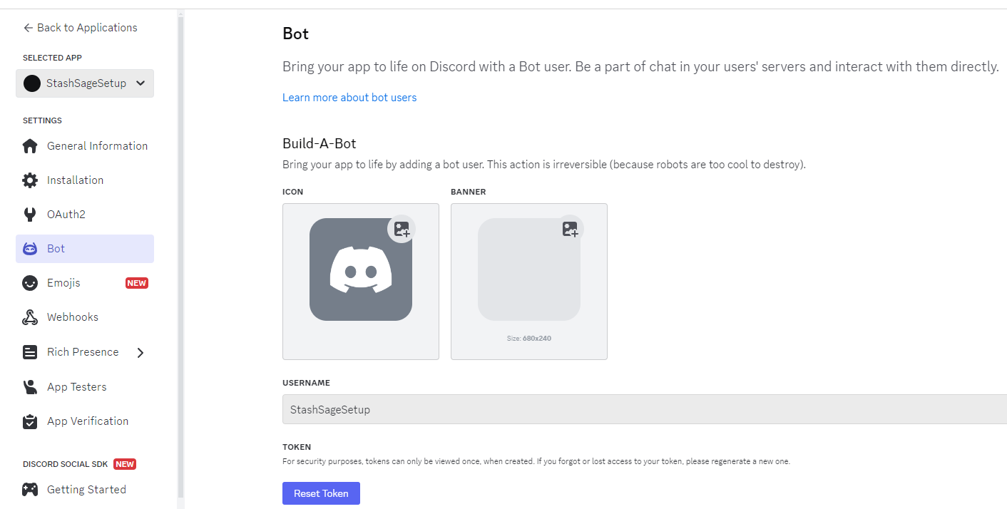
- Paste into “Discord Bot Token” in StashSage. Note: this is a very long string.
- Finally, go into Discord, access your User Settings with the gear icon in the bottom left near your avatar.
- On the left menu, find “Advanced” near the bottom, and then enable Developer Mode.

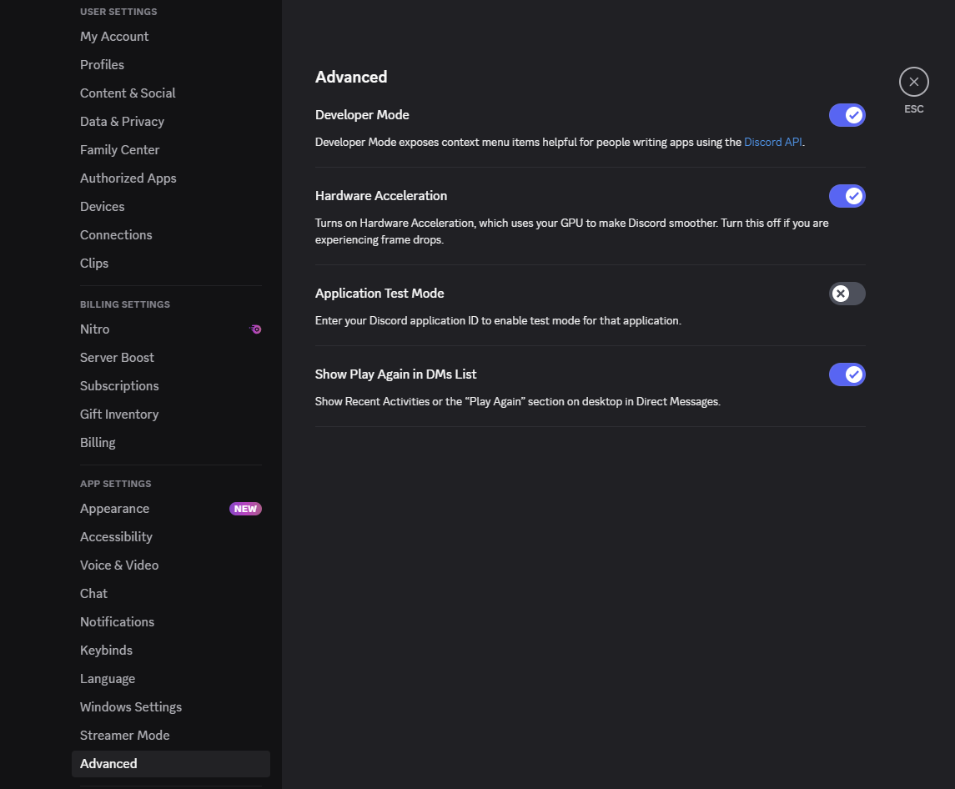
- Exit, click on your name, and “Copy User ID”. Paste this into the “Discord User ID”.
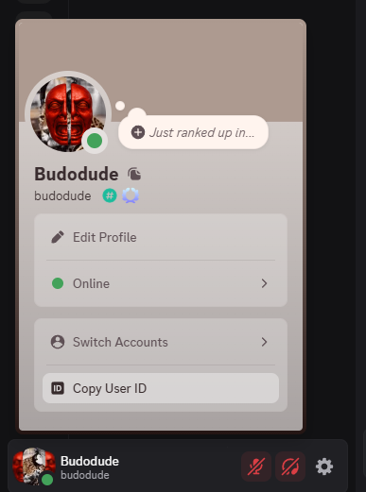
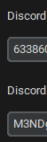
- Click “Save Settings & Reload”. If you’ve done everything correctly, the bot should now ping you

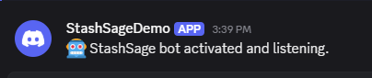
Congratulations! You’ve successfully setup your personal Discord bot and enabled the StashSage application to host your bot and send you messages about your stash trades!

